WEEK 10
Week Ending: |  |  | DAY: |  |  | Subject: Creative Arts And Design
Duration: 60MINS |  |  |  |  |  | Strand: Performing Arts
Class: B7 |  |  |  | Class Size: |  | Sub Strand: Creative and Aesthetic Expressions
Content Standard: Dance/Drama  B7.2.2.3. Demonstrate the ability to use concepts of design process (idea development) to produce and display own creative and expressive art-forms that reflect in the range of different times and cultures in dance and drama |  |  |  |  | Indicator:  B7.2.2.3.9 Organize an appreciation and appraisal of own and others’ artworks in dance and drama that reflect the history and culture of the people of the community |  |  | Lesson:  1 of 1
Performance Indicator:  Learners can show appreciation and appraisal of own and others artworks |  |  |  |  |  |  | Core Competencies:  PL5.2: PL6.1: CG5.4: PL6.2: DL5.3
Key words |  | Design, concept, artworks, aesthetic, organize, history, culture, display ,community plan venue, posters, appraisal, appreciation
Reference: Creative Arts And Design Curriculum P.g. 32
Phase/Duration | Learners Activities |  |  |  |  |  |  |  | Resources
PHASE 1: STARTER | Ask learners to play a stone passing game in small groups around their tables.  Recap of previous lesson using RCA technique.  Draw learners attention to the new lesson’s content standard and indicator(s).
PHASE 2: NEW  LEARNING | Guide learners to brainstorm on how to organize appreciation and appraisal events.  Show a poster, letter and/or notice, etc. to learners.  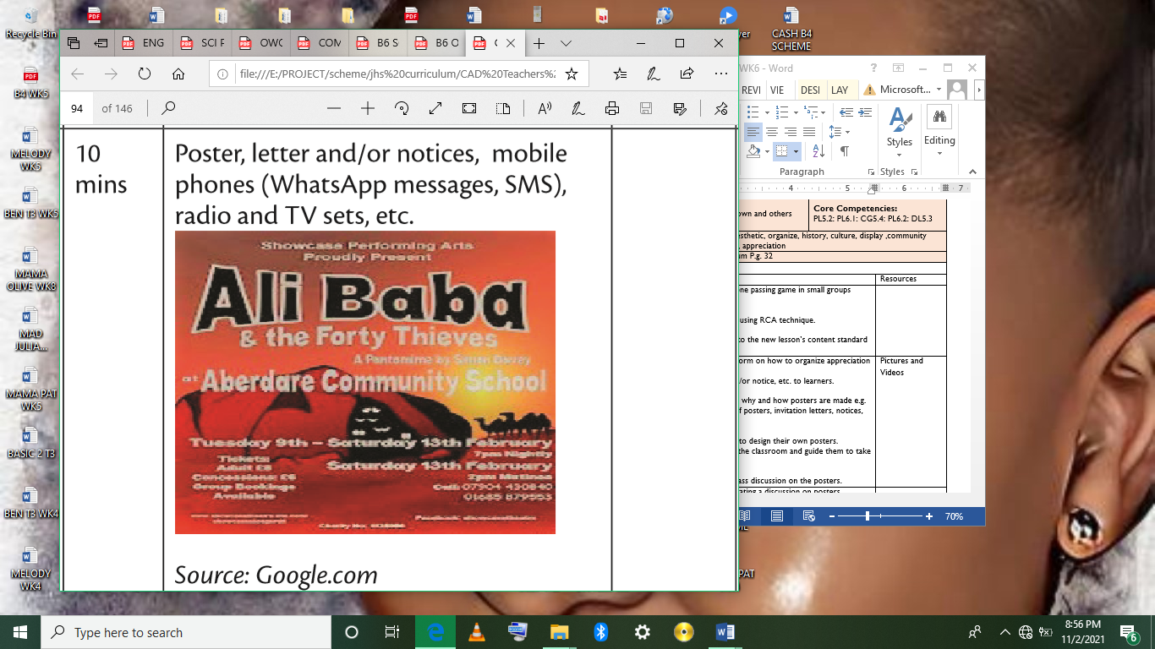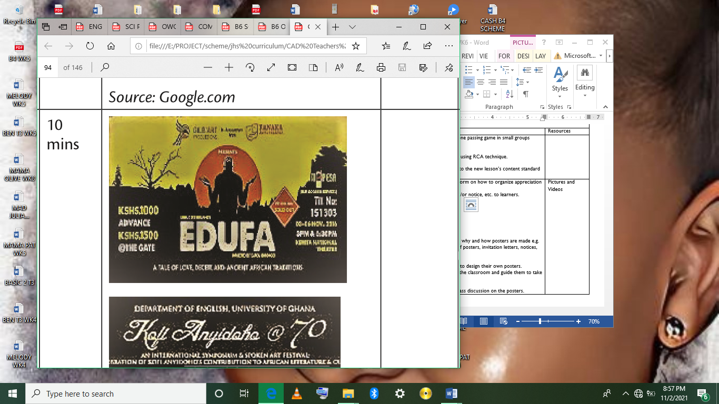  Guide learners to discuss why and how posters are made e.g. the uses or importance of posters, invitation letters, notices, etc.  In groups, guide learners to design their own posters.  Post learners’ posters in the classroom and guide them to take a gallery-walk.  Guide learners to do a class discussion on the posters. |  |  |  |  |  |  |  | Pictures and Videos
PHASE 3:  REFLECTION | Close the lesson by facilitating a discussion on posters designed by learners after the gallery-walk.  Summarize core-points for learners’ reflection.  Homework  Do further investigation on how to design posters for publicity for dance and drama performances. • Join community dance and drama groups.

